This assignment is designed to make sure you have done the basic software setup that will get you through the rest of the Data Science Specialization. Each component will be evaluated on a yes/no basis by your peers with 10 points assigned for each yes answer.

1. Install R
2. Install Rstudio
3. Open Rstudio and take a screenshot
4. Submit a screenshot of Rstudio open on your screen.

**Be careful not to have personally identifiable or important information visible in the screen shot!**

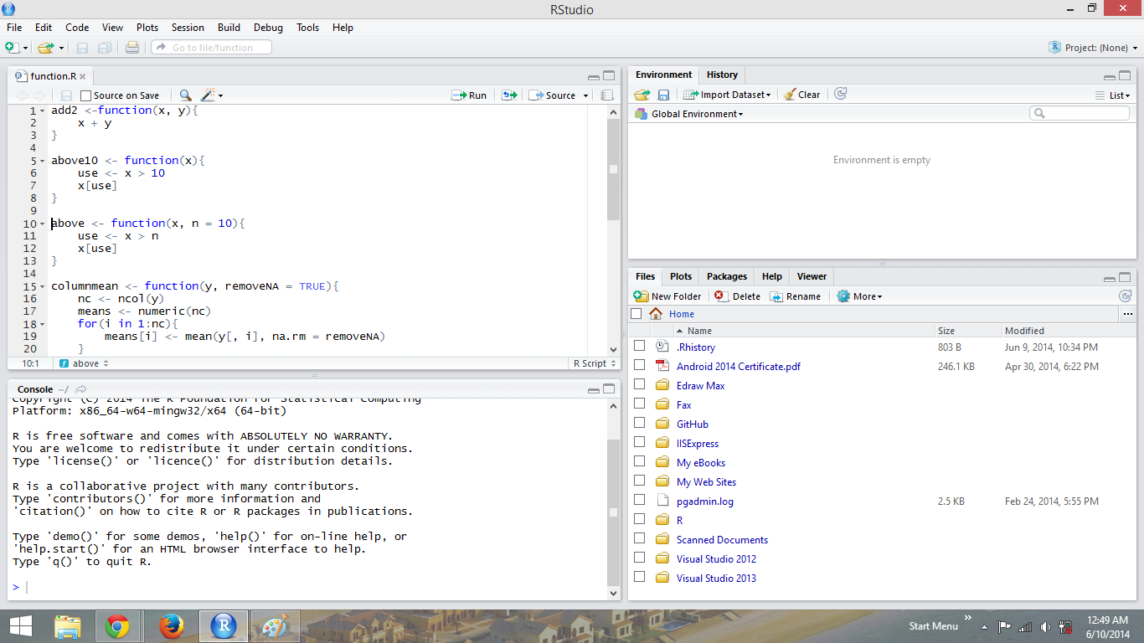

**Evaluation/feedback on the above work**

**Note**: this section can only be filled out during the evaluation phase.

From the screenshot is Rstudio open and installed?



1. Set up a Github account (you may use your own name or a pseudonym).
2. Create a repo called datasciencecoursera
3. Submit the link to your Github account

<https://github.com/tuanvu216/datasciencecoursera>

**Evaluation/feedback on the above work**

**Note**: this section can only be filled out during the evaluation phase.

The link is to an active Github account with the required repo.



1. Create a text file called HelloWorld.md
2. Add the line "## This is a markdown file" to the document
3. Push the document to the datasciencecoursera repo you created on Github
4. Submit the link to the HelloWorld.md file on your Github repo.

<https://github.com/tuanvu216/datasciencecoursera/blob/master/HelloWorld.md>

**Evaluation/feedback on the above work**

**Note**: this section can only be filled out during the evaluation phase.

The datasciencecoursera repo has the file HelloWorld.md in it.



1. Fork the data sharing repository here: <https://github.com/jtleek/datasharing>
2. Submit the link to the forked repository on your Github account.

<https://github.com/tuanvu216/datasharing>

**Evaluation/feedback on the above work**

**Note**: this section can only be filled out during the evaluation phase.

The link goes to a fork of <https://github.com/jtleek/datasharing> in the user's account.



**Overall evaluation/feedback**

**Note**: this section can only be filled out during the evaluation phase.

As far as you can determine, does it appear that the work submitted for this project is the work of the student who submitted it?



Please use the space below to provide constructive feedback to the student who submitted the work. Point out the submission's strengths as well as areas in need of improvement. You may also use this space to explain your grading decisions.



You've written 0 words